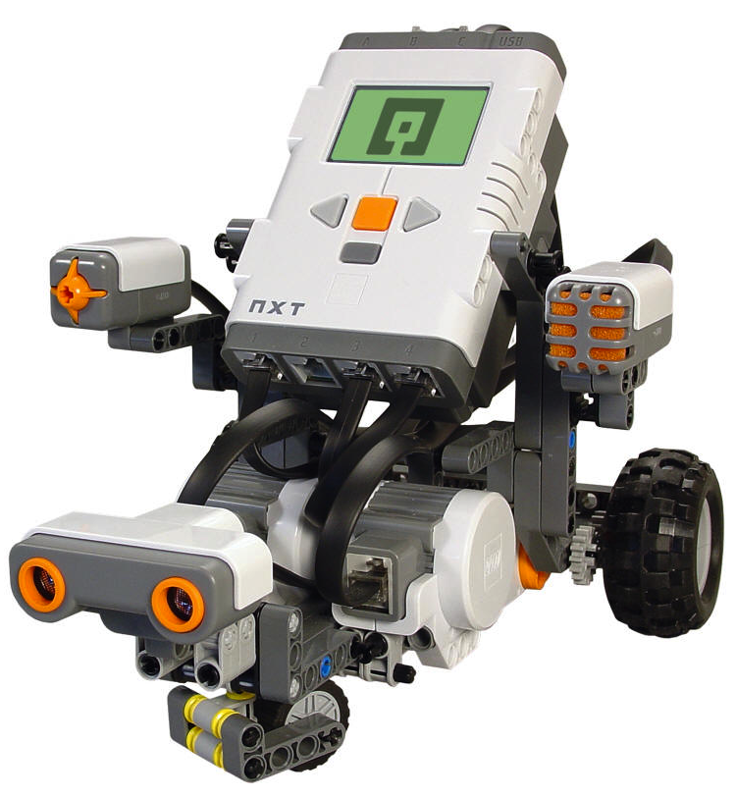

**PHYSICS** 1**Ø1**

SAMANTHA

April 2012

Jessicarae Nuñez

Rich Bakala

“MOVE UNTIL NEAR”

DATE

**THIS CERTIFIES THAT YOU HAVE SUCCESSFULLY DEMONSTRATED THE ROBOTIC BEHAVIOR**

Congratulations to the Engineering Team

**“MOVE UNTIL TOUCH/RELEASE”**

JOSH AND NATHAN

J.J. AND CO

April 2012

Jessicarae Nuñez

Rich Bakala

“MOVE UNTIL NEAR”

DATE

**THIS CERTIFIES THAT YOU HAVE SUCCESSFULLY DEMONSTRATED THE ROBOTIC BEHAVIOR**

Congratulations to the Engineering Team

**“MOVE UNTIL TOUCH/RELEASE”**

**PELE**

April 2012

Jessicarae Nuñez

WALLID

Rich Bakala

“MOVE UNTIL NEAR”

DATE

**THIS CERTIFIES THAT YOU HAVE SUCCESSFULLY DEMONSTRATED THE ROBOTIC BEHAVIOR**

Congratulations to the Engineering Team

**“MOVE UNTIL TOUCH/RELEASE”**

**WHERE’S THE BEEF**

April 2012

Jessicarae Nuñez

XAVIER AND ZACH

Rich Bakala

“MOVE UNTIL NEAR”

DATE

**THIS CERTIFIES THAT YOU HAVE SUCCESSFULLY DEMONSTRATED THE ROBOTIC BEHAVIOR**

Congratulations to the Engineering Team

**“MOVE UNTIL TOUCH/RELEASE”**

ZACH AND SABER

**HARRY AND THE POTTERS**

April 2012

Jessicarae Nuñez

Rich Bakala

“MOVE UNTIL NEAR”

DATE

**THIS CERTIFIES THAT YOU HAVE SUCCESSFULLY DEMONSTRATED THE ROBOTIC BEHAVIOR**

Congratulations to the Engineering Team

**“MOVE UNTIL TOUCH/RELEASE”**

MARK AND HENRY

ROBOT MASTERS

April 2012

Jessicarae Nuñez

Rich Bakala

“MOVE UNTIL NEAR”

DATE

**THIS CERTIFIES THAT YOU HAVE SUCCESSFULLY DEMONSTRATED THE ROBOTIC BEHAVIOR**

Congratulations to the Engineering Team

**“MOVE UNTIL TOUCH/RELEASE”**

TRISTAN AND JOSE

**J.T. CO.**

April 2012

Jessicarae Nuñez

Rich Bakala

“MOVE UNTIL NEAR”

DATE

**THIS CERTIFIES THAT YOU HAVE SUCCESSFULLY DEMONSTRATED THE ROBOTIC BEHAVIOR**

Congratulations to the Engineering Team

**“MOVE UNTIL TOUCH/RELEASE”**

**THE OTHER GUYS**

JAKE AND RILEY

April 2012

Jessicarae Nuñez

Rich Bakala

“MOVE UNTIL NEAR”

DATE

**THIS CERTIFIES THAT YOU HAVE SUCCESSFULLY DEMONSTRATED THE ROBOTIC BEHAVIOR**

Congratulations to the Engineering Team

**“MOVE UNTIL TOUCH/RELEASE”**

**TEAM SWAG**

GARRETT

April 2012

Jessicarae Nuñez

Rich Bakala

“MOVE UNTIL NEAR”

DATE

**THIS CERTIFIES THAT YOU HAVE SUCCESSFULLY DEMONSTRATED THE ROBOTIC BEHAVIOR**

Congratulations to the Engineering Team

**“MOVE UNTIL TOUCH/RELEASE”**

**THE SUPERMAN’S**

BRITTANY AND EMMA

April 2012

Jessicarae Nuñez

Rich Bakala

“MOVE UNTIL NEAR”

DATE

**THIS CERTIFIES THAT YOU HAVE SUCCESSFULLY DEMONSTRATED THE ROBOTIC BEHAVIOR**

Congratulations to the Engineering Team

**“MOVE UNTIL TOUCH/RELEASE”**